A Two-Day Hands-on Workshop on “Computational Modelling of Renewable Energy Systems Using MATLAB

Proposed to be conducted on 04-02-2026 and 05-02-2026

Organized by
Dept of ELECTRICAL AND ELECTRONICS ENGINEERING-SCET
Academic Year: 2025-26
Targeted Students: III Year EEE students

Resource Person
Dr K. Pavan Kumar Assoc Prof, Aditya University

Coordinator Co-coordinator
Dr. Satyanarayana Addala Mrs N Lavanya
HOD- EEE Asst prof






CONTENTS
- Boucher.
- Program Objectives.
- Workshop Schedule.
- About the Resource Person.
- Target Participants.
- Programme Outcome vs PO/PSO Mapping
- Photographs
- Conclusion

Boucher

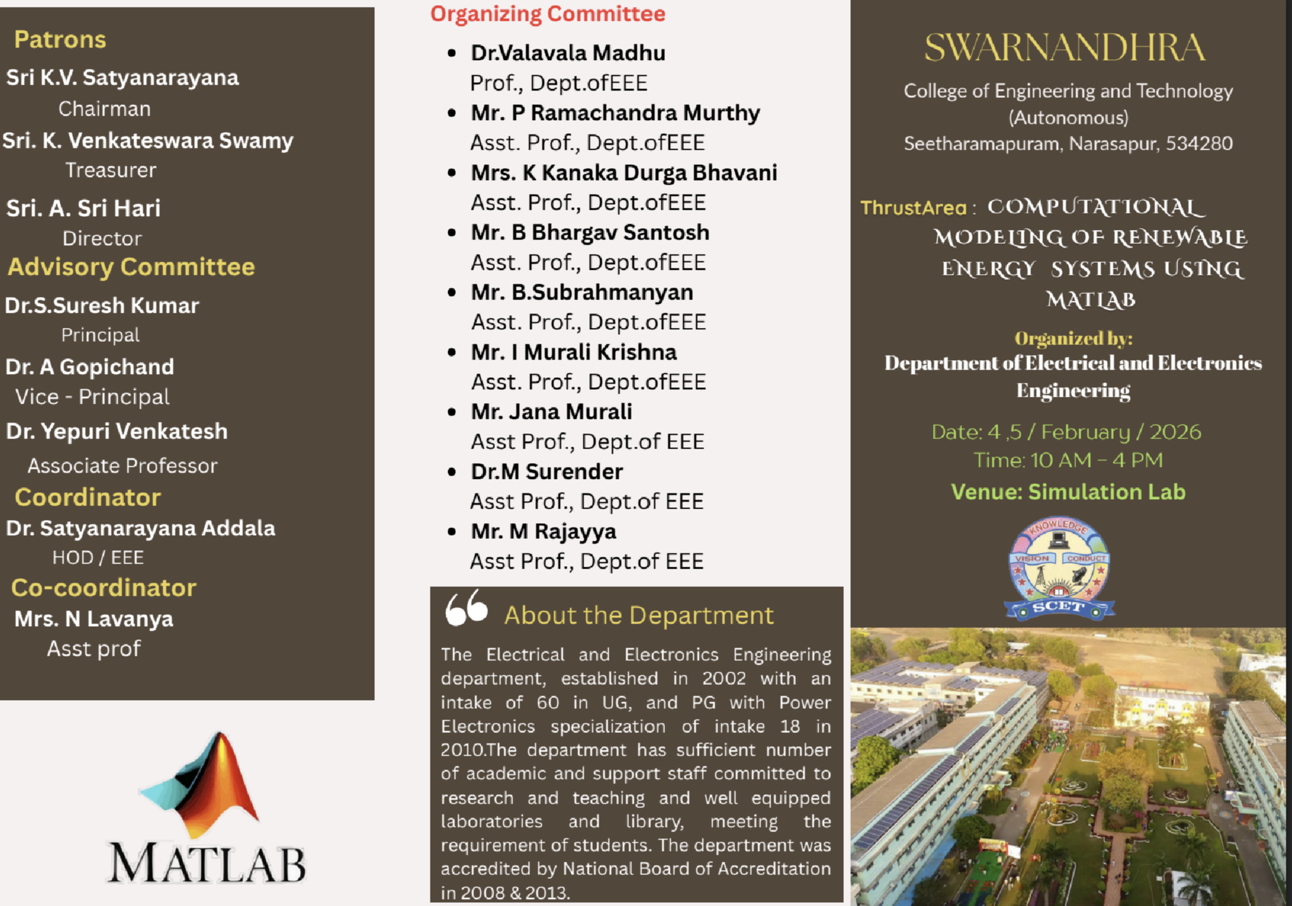
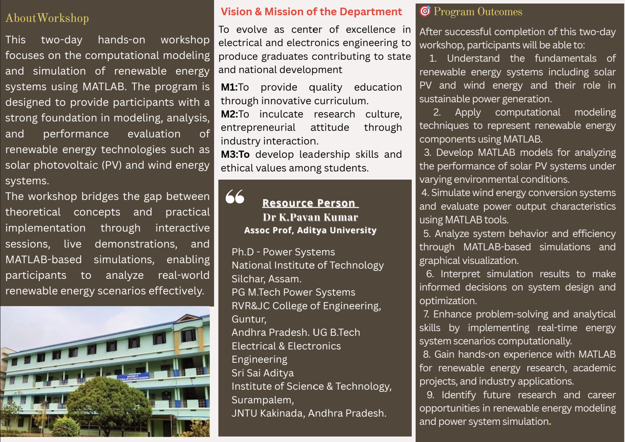

Program Objectives:
The primary objective of this two-day hands-on workshop on “Computational Modelling of Renewable Energy Systems Using MATLAB” is to equip III-year Electrical and Electronics Engineering students with practical knowledge and computational skills required to model, analyse, and simulate renewable energy systems.
The specific objectives of the programme are to:
- Introduce students to the fundamentals of renewable energy systems and their role in sustainable power generation.
- Develop proficiency in using MATLAB for mathematical modelling and simulation of renewable energy sources.
- Enable students to model and analyse solar PV, wind energy and hybrid renewable energy systems.
- Provide hands-on experience in performance evaluation, system behaviour analysis, and result interpretation.
- Bridge the gap between theoretical concepts and real-world applications through practical case studies.
- Enhance problem-solving, analytical, and computational skills relevant to modern power and energy engineering.

Workshop Schedule.
Day 1: Fundamentals of PV System
Time | Session Title | Description
9:30 AM – 10:00 AM | Inauguration & Overview | Welcome address, objectives of the workshop.
10:00 AM – 11:30 AM | Session 1: Introduction to PV System | Overview of PV System
11:30 AM – 11:45 AM | Break
11:45 AM – 1:00 PM | Session 2: Modelling Solar PV System | Mathematical modelling of solar cells and PV modules using equivalent circuit equations.
1:00 PM – 2:00 PM | Lunch Break
2:00 PM – 3:30 PM | Session 3: Introduction to MATLAB | Basics of MATLAB environment, script writing, and an introduction to Simulink blocks.
3:30 PM – 4:00 PM | Session 4: Hands on Session on MATLAB/Simulink | Building a basic PV module block and analyzing I-V and P-V characteristics.

Day 2: Modelling off grid/on grid Solar PV System
Time | Session Title | Description
9:30 AM – 11:00 AM | Session 5: Modelling off-grid/on-grid Solar PV System | System configuration for standalone and grid-connected systems, including inverter control.
11:00 AM – 11:15 AM | Break
11:15 AM – 1:00 PM | Session 6: Estimation of Solar Radiation | Methods for calculating solar irradiance using PVSYST
1:00 PM – 2:00 PM | Lunch Break
2:00 PM – 3:30 PM | Session 7: Hands on Session on MATLAB/Simulink | Simulation of a complete system with MPPT (Maximum Power Point Tracking) controllers.
3:30 PM – 4:00 PM | Valedictory & Feedback | Feedback, future scope discussion

About Resource Person:
Resource Person Details
Name: Dr. K. Pavan Kumar
Designation: Associate Professor
Affiliation: Aditya University
Educational Qualifications:
Ph.D. in Power Systems, National Institute of Technology, Silchar, Assam
M.Tech in Power Systems, RVR & JC College of Engineering, Guntur, Andhra Pradesh
B.Tech in Electrical & Electronics Engineering, Sri Sai Aditya Institute of Science & Technology, Surampalem, JNTU Kakinada, Andhra Pradesh.

Target Participants.
WORKSHOP ATTENDANCE SHEET
Workshop title: A Two-Day Hands-on Workshop on Computational Modelling of Renewable Energy Systems Using MATLAB.
Date of the workshop: 04-02-2026 & 05-02-2026.
Target students: III EEE Students.
Venue / location: EEE Simulation Lab-SCET
Organized by: Dept. of Electrical and Electronics Engineering
Resource Person: Dr. K.K. PAVAN KUMAR, Assoc. Prof, EEE Dept. Aditya University.
S.NO | Regd No | NAME OF THE STUDENT
1 | 23A21A0201 | ALLA BABY DURGA NAGASUPRIYA
2 | 23A21A0207 | CHUKKA SUMATHI
3 | 23A21A0210 | DUSANAPUDI MOHAN SURENDRA
4 | 23A21A0211 | DUSANAPUDI YAMINI
5 | 23A21A0213 | GIDDA GEETANJALI
6 | 23A21A0214 | GOPU SANDHYA DEVI
7 | 23A21A0217 | GUNDABATHULA UHA LAKSHMI SALINI
8 | 23A21A0219 | ILLA HANU HANISH
9 | 23A21A0220 | KADALI LEELA MADHURI
10 | 23A21A0222 | KANUKOLANU SRI SANTHOSHI MEGHANA
11 | 23A21A0223 | KOPPARTHI PRAVALLIKA
12 | 23A21A0233 | NADAPANA USHASRI
13 | 23A21A0237 | PERURI TULASI NAGA KRISHNA VENI
14 | 23A21A0240 | PONNAPALLI NARASIMHA SWAMY
15 | 23A21A0242 | PULI NANDINI
16 | 23A21A0248 | SIMHADRI VENNELA SRI LAKSHMI
17 | 23A21A0249 | NADAPANA PRAVALLIKA
18 | 24A25A0201 | DEVIREDDY PRASANTH GANESH
19 | 24A25A0203 | JAGATHA JAGADEESWAR
20 | 24A25A0204 | KARRA JNANA SHANKAR
21 | 24A25A0205 | KASINA SRI NAGA DURGA VARA PRASAD
22 | 24A25A0206 | KUNUKU JAYA SRI SAI MOUNIKA
23 | 24A25A0207 | MAJJI VAMSI RAMA KRISHNA
24 | 24A25A0208 | MANEPALLI NAGA VENKATA JATHIN KUMAR
25 | 24A25A0209 | MARLA LOHITH
26 | 24A25A0211 | NALLI JOHNSON
27 | 24A25A0212 | NANDAMURI NANDAKISHORE
28 | 24A25A0213 | PALA RAJU
29 | 24A25A0214 | PULAGAM YUGAENDHAR
30 | 24A25A0215 | RANGINEEDI SRI DEVI NAGASUDHEER
31 | 24A25A0217 | TUMMALAPALLI ARAVIND
32 | 24A25A0219 | VINUKULA RAMU
33 | 24A25A0220 | SANNIDHI SRI VINAY HARI NAVADEEP
34 | 24A25A0221 | KUSUMA ROHAN
35 | 24A25A0222 | KODURI HARSHA VARDHAN

Programme Outcome vs PO/PSO Mapping.

Programme Outcomes (POs)
PO No. | Programme Outcome | Mapping Level | Justification
PO1 | Engineering knowledge | 3 | Application of mathematics, power systems, and renewable energy concepts in MATLAB models
PO2 | Problem analysis | 3 | Analysis of renewable system performance, losses, and efficiency
PO3 | Design/development of solutions | 2 | Modelling and simulation of solar, wind, and hybrid systems
PO4 | Conduct investigations of complex problems | 2 | Simulation-based performance evaluation and result interpretation
PO5 | Modern tool usage | 3 | Extensive use of MATLAB/Simulink for computational modelling
PO6 | Engineer and society | 1 | Awareness of renewable energy’s societal impact
PO7 | Environment and sustainability | 3 | Emphasis on clean and sustainable energy systems
PO8 | Ethics | – | Not explicitly addressed
PO9 | Individual and teamwork | 2 | Hands-on exercises and collaborative modelling activities
PO10 | Communication | 1 | Discussion of results and interpretations
PO11 | Project management and finance | – | Not addressed
PO12 | Life-long learning | 2 | Exposure to emerging renewable technologies and tools

Programme Specific Outcomes (PSOs)
PSO No. | Programme Specific Outcome | Mapping Level | Justification
PSO1 | Apply domain knowledge to renewable energy systems | 3 | Modelling of solar PV, wind, and hybrid energy systems
PSO2 | Use modern computational tools for system analysis | 3 | MATLAB-based simulation and analysis
PSO3 | Develop sustainable and efficient energy solutions | 2 | Performance optimization through modelling

Photograph
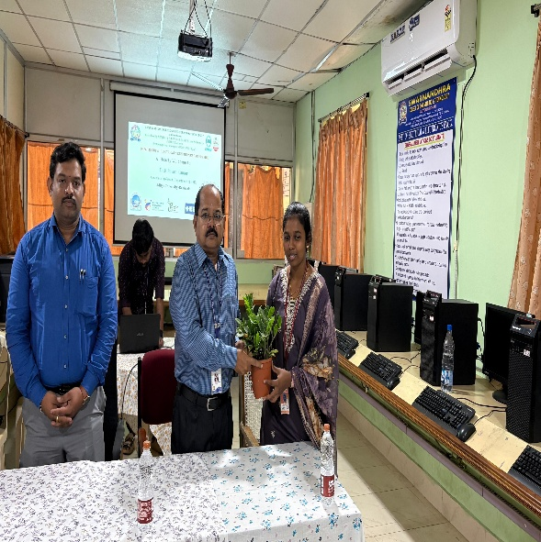
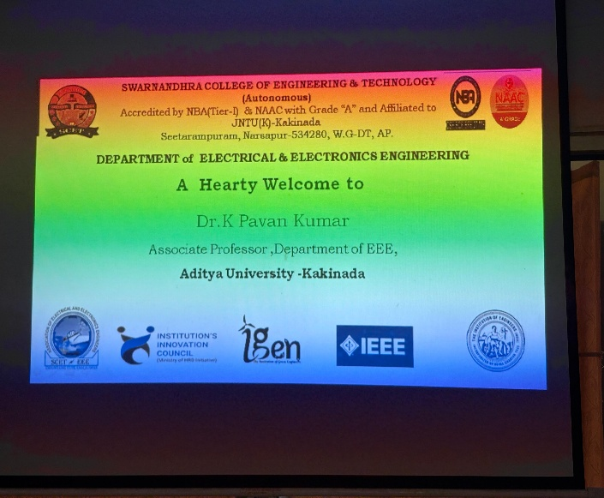

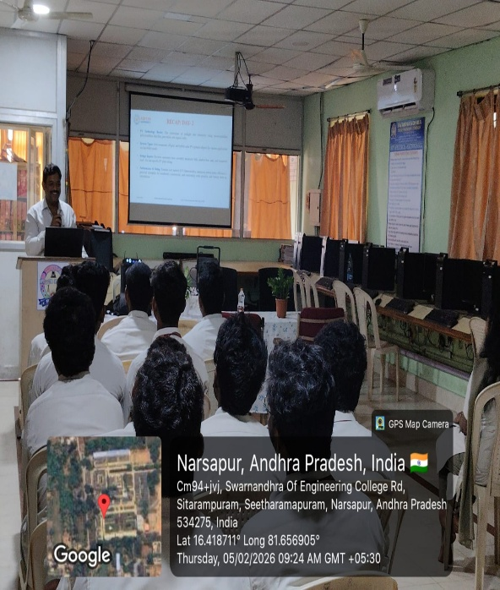
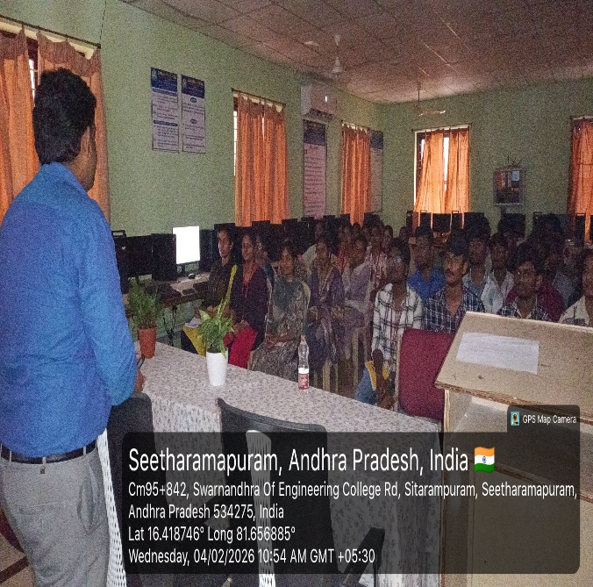

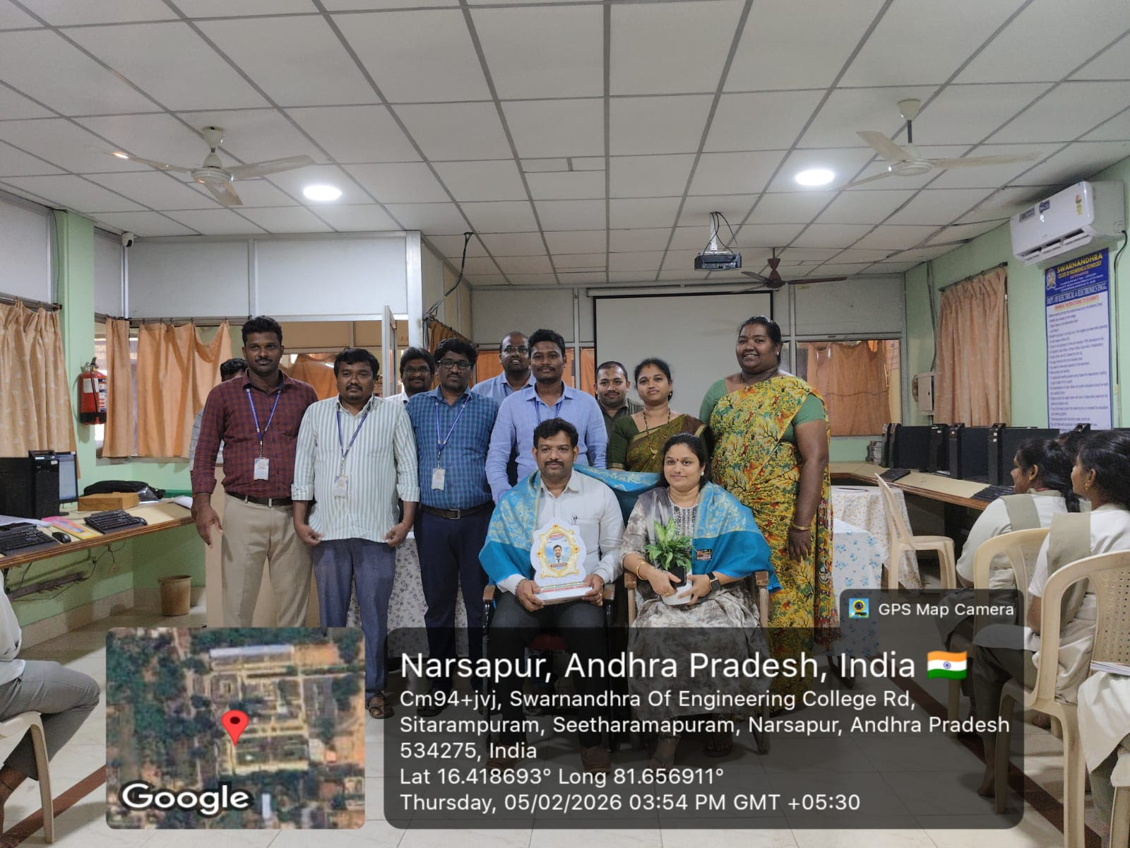

Conclusion.

The two-day hands-on workshop on “Computational Modelling of Renewable Energy Systems Using MATLAB” successfully provided participants with a strong foundation in photovoltaic (PV) system concepts and their practical implementation using MATLAB/Simulink. The sessions were systematically structured, beginning with the fundamentals of PV systems and progressing toward advanced modelling of off-grid and on-grid solar PV systems.
Through a balanced mix of theoretical discussions and hands-on simulation exercises, participants gained practical exposure to solar cell modelling, I–V and P–V characteristic analysis, system configuration, MPPT control techniques, and solar radiation estimation. The interactive MATLAB/Simulink sessions enabled attendees to translate theoretical knowledge into real-time simulations, enhancing their analytical and problem-solving skills.
Overall, the workshop achieved its objectives by strengthening participants’ understanding of renewable energy system modelling and equipping them with essential computational tools relevant to research and industry applications. The positive feedback received during the valedictory session reflected the effectiveness of the workshop and highlighted its relevance in addressing the growing demand for skilled professionals in the renewable energy sector.

